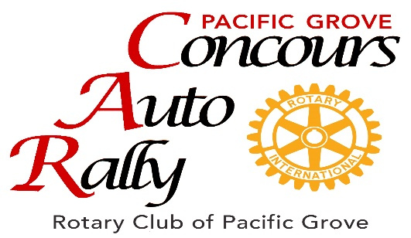

2023 PROGRAM ADVERTISING RATES

 | AD SIZE | AD PRICE
 | Business Card Color* | 80.00
 | 1/8th Page- Color | 135.00
 | Quarter Page - Color | 230.00
 | Half Page - Color | 430.00
 | Full Page - Color | 800.00

AD CONTENT: The advertiser must provide ad copy no later than July 1, 2023 @ 5:00PM.
AD SPECIFICATIONS: Only digital files accepted with the exception of business card ads.
If you have a business card that you would like to use, but do not have a digital copy, in
Addition to the cost of the ad, there will be a $15.00 per card fee to scan and enhance the business card. Ads must be done in Photoshop or PDF files. Photos/PDF files
must be a minimum of 300dpi at print size. Please Email a complete, “ready to print
advertising file” ad only to: jcbarchfaia@att.net and note “2023 Auto Rally Final Ad”
and include your business name, in the “subject line” of your Email.
COMPLETE and SIGN the agreement form and return along with your Check to:
Pacific Grove Rotary Concours Auto Rally, PO Box 51453, Pacific Grove, CA 93950

- For Information about rates or if you have any questions please contact:
Vic Johnson 831-647-0205 or Lindsay Munoz 209-607-2488

Pacific Grove Rotary Concours Auto Rally
PO Box 51453 Pacific Grove CA 93950
(831) 372-3861 pgautorally@gmail.com pgautorally.org

